Dar Al-Hekma University Hekma
School of business and law 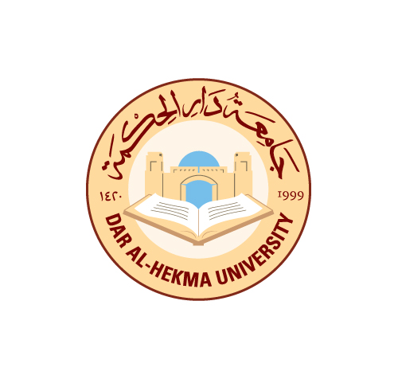
Academic Risk Identification on Students Internship Program

Potential  Risk/Hazard |  | Risk Level | Risk Mitigation | Responsible
Student injury |  | Low | 1. Students are notified that in this case, it is under their personal health insurance.  2. Students sign forms before their internship starts. | Student's advisor and the student
Student injury to others |  | Low | 1. Responsibility of the student to compensate the other party.  2. Students sign forms before their internship starts. | Student's advisor and the student
Student property damage |  | Low | 1. Students own responsibility.  2. Students sign forms before their internship starts. | Student's advisor and the student
Student damage to property of others |  | Medium | 1. Student's responsibility to compensate for the damage.  2. Students sign forms before their internship starts. | Student's advisor and the student
Student roles and responsibilities during assignment |  | High | 1. Three progress reports are to be submitted to the academic advisor. | Students advisor and the student
Host entity role and responsibility |  | High | 1. Signed agreement which includes the following:  a. set duties and responsibilities  b. maintain students attendance  c. avail office space and all needed equipment, info, etc. to maintain the students assigned tasks  d. liaise with the academic advisor  2. A copy of the signed agreement is kept by all parties. | All concerned parties
Safety at the work site |  | High | 1. Part of the internship agreement.  2. Select reputable business and sites for internship.  3. Visit at least twice the selected organizations.  4. Ensure that the organization is aware about the importance of organizational safety. | Department/student
Host Harassment at the work site |  | Medium | 1. Raise student's awareness about the different forms of harassment.  2. Select reputable business and sites for internship.  3. In case of any form of harassment arises, the student should notify her academic advisor to take corrective action and if necessary, terminate the agreement. | All concerned parties
Student harassment towards the work site employees | Low |  | Terminate the agreement.

Internship Course Leader (Dar Al-Hekma College )  Name:_________________________  Signature:______________________  Date:___________________________ | Internship Course Supervisor (insert name of organization )  Name:_________________________  Signature:______________________  Date:___________________________
Student Information (Dar Al-Hekma College )
Name:_________________________
Program title:___________________
Signature:______________________
Date:__________________________

